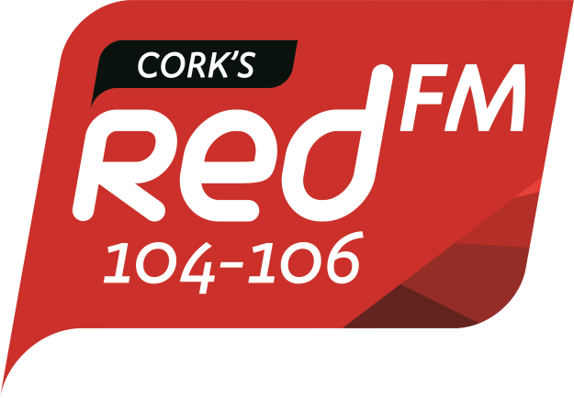

Cork’s RedFM Complaint Form

Your Name: _____________________

Your Address: _____________________
_____________________
_____________________
_____________________
_____________________

Date of Broadcast: _____________________

Time of Broadcast: _____________________

Name of programme/news item/advertisement/commercial communication:

__________________________________________________________

What do you believe the item to be an infringement of?
Please select category & indicate which section of the code is applicable
Broadcasting Act 2009 Section 48(1)(a) objectivity & impartiality in news;
Broadcasting Act 2009 Section 48(1)(a) fairness, objectivity & impartiality in current affairs;
Broadcasting Act 2009 Section 48(1)(b) harm & offence (Code of Programme Standards
Broadcasting Act 2009 Section 48(1)(b) law & order;
Broadcasting Act 2009 Section 48(1)(c) privacy of an individual.
Broadcasting Act 2009 Section 48 (1)(d) General Commercial Communications Code
Broadcasting Act 2009 Section 48 (1)(d) Children’s Commercial Communications Code

When submitting a complaint under b) harm & offence, complainants can refer to ‘The Code of Programme Standards’. This Code details a range of factors that may be taken into account when determining whether programme material is harmful or offensive. The main headings in the Code are:
Content Principles | Content Rules
2.1 General Community Standards  2.2 Due Care  2.2.1 audience information & guidance  2.2.2 identification with characters, actions and personal circumstances  2.3 Protection for Children  2.4 Assessment - programme material shall be assessed in whole and in context | 3.1 Violent Programme Material  3.2 Sexual conduct  3.3 Coarse & Offensive Language  3.4 Persons and Groups in Society  3.5 Factual Programming – News, Current Affairs and Documentaries  3.6. Children’s Programming  3.7 Drugs, Alcohol and Solvent Abuse  3.8 Imitative Behaviour

When submitting a complaint concerning a commercial communication, a complainant may refer to the Children’s Commercial Communications Code or the General Commercial Communications Code.
General Commercial Communications Code | Children’s Commercial Communications Code
Main Sections: -  3 General principles and rules applying to all commercial communications (including the protection of the individual & society; offence, harm and human dignity; transparency; and assessment)  4 General rules pertaining to advertising and teleshopping  5 Rules pertaining to specific advertising techniques  6 Rules pertaining to sponsorship (including competitions)  7 Television Product Placement  8 Rules pertaining to specific products and services  9 Prohibited communications  10 Appendix (a list of principal legislation that may affect commercial communications) | Main Sections: -  5 Social values  6 Inexperience and credulity  7 Undue pressure  8 Special protection for children in advertising  9 General safety  10 Violence  11 Diet and Nutrition  12 Parental responsibility  13 Programme characters  14 Children’s advertising, sponsorship & product placement  15 Prohibitions & Restrictions

Copies of the Codes are available on the BAI website, http://www.bai.ie/ or on request from the BAI’s offices.

What concerns you about this item? If your complaint concerns a breach of the BAI Codes, please specify what section of the Code.

